LOADING SHAW REPORTS TO A NEW CATALOG

PREPARATION
- For this example, we’ll install the piping through lengths custom report in a new catalog. These steps apply for any situation when you need to bring Shaw reports into a new plant’s catalog
- Procure file Manabi Pipeline Length.rar from \\swidenapp02\SP3D_DEV\Training_Material\REPORTS
- Extract this rar’s contents to the local SP3D server, i.e. d:\SP3D_DEV\Reports
- Copy the custom dll to your centralized location for custom utilities and commands, i.e. in Houston we use \\houfs07\VDrive\SP3D\STD_CustomDLLs\Reports
- Register the new dll “SP3DReportLabel.dll”. There is a bat file named RegisterReportLabel.bat together with this dll that you can edit to simplify this step for future users

CONFIGURING REPORT
- Enter SP3D and go to Tasks>Drawings and Reports
- Create a new spreadsheet report (this procedure assumes you already know how to create a basic report and save it to catalog) using any of the Ingr delivered report templates for piping. For this example “Piping Pipelines Sorted by Name” was used as the template
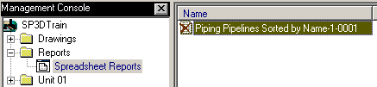
- Rename the resulting report. Give it the exact same name as the report you mean to import from another SP3D plant. In this example we are importing a report named Pipeline Length from the Manabi project.
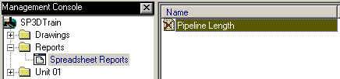
- Right click the new report and select Edit Template
- Under Report Description enter “Piperun Through Lengths and Tracing” (Or any other description as appropriate for the report format you are importing)
- While in template edit mode, select File>Save Report Template
- Select OK/Finish if a Filter and/or Report Parameters dialogs pop up. No need to interact with them
- Click “Spreadsheet Reports” to get out of edit template mode
- Right click Pipeline Length (or any other name used for the report you are importing), and select Copy to Catalog…
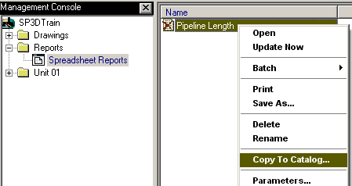
- The Select Location form appears
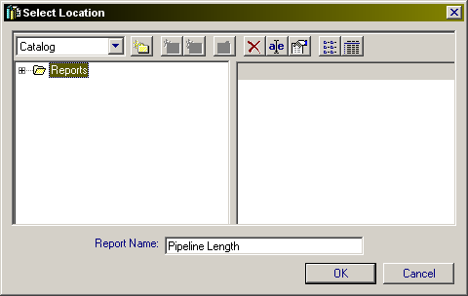
- Expand the root folder “Reports”
- With the root folder still highlighted, select the create folder option
- A new folder appears, set its name to _Shaw and press Enter
- Notice that the Report Name is already set to your template name per the report just saved, in this example Pipeline Length
- Select OK to save this report as a template in the catalog under the _Shaw folder
- To verify the new template, right click Spreadsheet Reports and select Create Report…
Under the _Shaw folder you should find the new template, i.e.
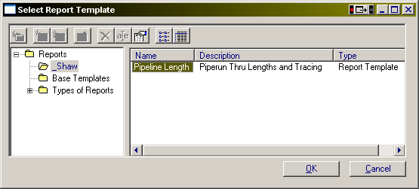

IMPORTING QUERY AND FORMAT FILES FROM ANOTHER SYMBOLS SHARE
- The previous steps only created the pointer to the template. The next step is to import the actual template files from another plant’s symbols share.
Locate the query and format files (.rdy/.rfm/.rfp/.rqe/.rtp/.xls) from the source plant’s symbols share. For this example they are stored in the rar archive “Manabi Pipeline Length.rar” from \\swidenapp02\SP3D_DEV\Training_Material\REPORTS
- Locate the new template query and format files folder in the active plant’s symbols share reports folder. It will be found under …reports\_Shaw. Our example is using the training plant’s student symbols share:
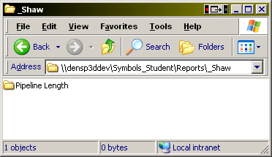
- (optional) create a backup of the existing template folder, i.e. Pipeline Length.zip
- Replace the contents of the template folder with the query and format files from the source plant. For our example, we will drag and drop the Pipeline Length files from the “Manabi Pipeline Length.rar” archive into the Pipeline Length folder
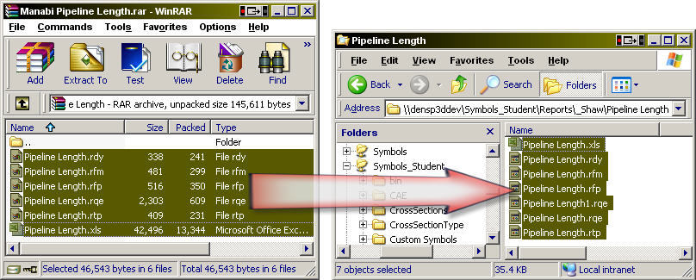
- IMPORTANT: If your active plant already has the Shaw drawings and reports filters copied into its catalog, then the filters called by reports like Pipeline Length will already be in place. But if that’s not the case, perhaps if you are importing a non standard report template, then the necessary filter may need to be created for the new template to work

VERIFYING REPORT FILTER

In Drawings and Reports task, delete the old report used to create the template. In our example we delete Pipeline Length (this deletes just the old report, not the template).
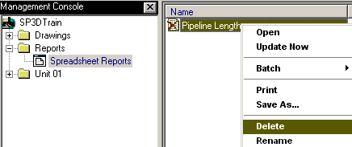

Right click on Spreadsheet Reports and select option to create a new report.
Use the new template under _Shaw to create the new report. If the copied template files settings have any issues, the system will report that in a dialog. If that’s the case click OK:
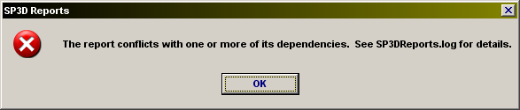
If you do not see this error and the new report is created, skip the rest of this section.

The contents of the SP3DReports.log in the %TEMP% folder will likely read as follows:
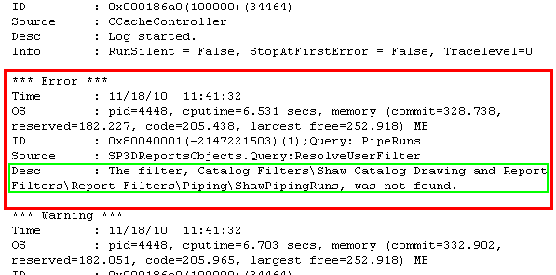

OR:
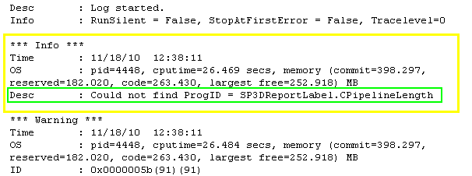

The yellow info error indicates that the new dll “SP3DReportLabel.dll” was not registered earlier. Register it at the workstation/server where this procedure is being executed at, per the initial steps in this document

The red error indicates that the Shaw standard drawings and reports filters do not exist in this plant
One alternative is to copy over the Shaw filters from another active catalog. Contact Rick Edler about having this done
For our purposes we will create the necessary filter manually.

Go to the active plant where the report template was copied from. In Common task open for edit the filter specified in the error message (red/green inner box above). In our case it’s “ShawPipingRuns” under the Shaw drawing and report filters folder.
- Take note of the Filter settings (make screenshots if needed). In our example the System and Object Type tabs require the following settings:
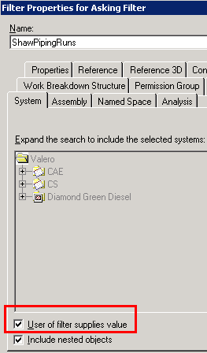…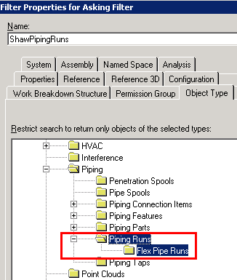
- Return to the new plant where the report is being imported
- In Common task select Tools>Select by Filter
- Select Catalog Filters and use the create folder option to create the Shaw filters hierarchy for piping filters:
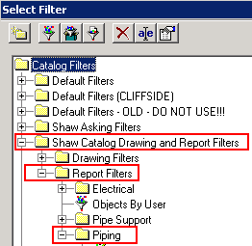
Note: This is done automatically when filters are copied from another catalog
- Select the last Piping folder in this hierarchy and create the necessary filter using the information from the steps above. In our example that would be ShawPipingRuns
- If possible, test the filter while in graphics. In our example running the filter will ask the user for a unit or area selection in the filter form, after selecting OK, all piperuns in the selected units or areas will be selected
- FYI: It is possible to create the filter elsewhere, and then manually edit the report’s query template (back door) to point the report to that new filter. Contact Rick Edler for details on using this option
- Return to Tasks>Drawings and Reports
- Right click on Spreadsheet Reports and select option to create a new report.
Use the new template under _Shaw to create the new report

TESTING THE NEW TEMPLATE
- During creation of a new report using the new template, the system may prompt for filter and/or dimension parameter settings. In our example it prompts the user for areas or units to process, then it asks for report parameters settings (primary/secondary units, precision type, etc.) Define these parameters as needed for the report
- The new report should get created using the new template, i.e.
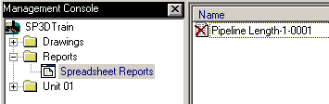
- Right click on the report and run update now on it. If all goes well the green check will indicate success
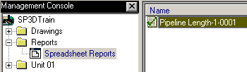

- Enter the report and verify that it has the required format and information. In my case I seem to have a problem with missing nom sizes for the piperuns…
- 